Validation of SWMFIE Kamodo interpolator and visualization against CCMC online Visualization.

SWMF-IE 4D:

1. Loaded 1 hour of outputs from run into swmie_4Dcdf.ipynb notebook.
2. Set time slice to 0.4 (00:24 UT)
3. Ran notebook with updated settings (see page 2), cells 3 and 5.
4. Perform matching CMC online visualization:

Load run page for SWMF run Yi-De_Jing_042221_1 (<https://ccmc.gsfc.nasa.gov/results/viewrun.php?domain=GM&runnumber=Yi-De_Jing_042221_1>):

* 1. Perform [2D Ionosphere Electrodynamics](https://ccmc.gsfc.nasa.gov/cgi-bin/run_iono2d.cgi?dir=27865) visualization for a given time (longitude-latitude):

Select time step (00:24:00 UT of the first day in the run)

Select variable to plot (SigmaP or JR)

Select Color Contour plot mode

Select 0 as the lowest latitude (hemispheres cover the whole Earth) or a latitude > 0 (focus on polar regions)

The polar plots rendered by default are different from the rectangular lon-lat plots in the notebook but checks include if auroral and solar EUV background patterns are in the correct hemisphere.

In the online visualization lat=0 (or lat=360) appears at the top of the polar plots (local noon, Sun is above the plots).

Online visualization can return positions and values inn a text file.

The positions could be fed into the Kamodo notebook to request similar values from the interpolator.

* 1. [Timeseries in 2D Ionosphere](https://ccmc.gsfc.nasa.gov/cgi-bin/run_timeseries_iono.cgi?dir=27865) visualization:

Follow the “generate timeseries in ionosphere electrodynamics” link from the run page.

Set up a line in space to track using start point (lon_1,lat_1) and end point (lon_2,lat_2) to define a line, either with a constant longitude or constant latitude.

A. Lon=constant: lon_1 = lon_2 and lat_1 <> lat_2

B. Lat=constant : lon_1 <> lon_2 and lat_1=lat_2

Select time range matching the data read in the notebook

Select 2D Color Contour to request the applicable plot.

Data outputs may be requested and date, times and locations can be fed into Kamodo to compare values.

Notebook SWMFIE_4Dcdf.ipynb—updated settings for the purpose of this comparison:

**Cell 3:**

file_prefix = '/Users/lrastaet/Kamodo_data/SWMF_IE/Yi-De_Jing_042221_1_SWMF_IE/i_e20080501-00'

**Cell 5:**

#set variables to be plotted

if gridded_int: #set list of variables to check plots, list should include at least one 3D and at least one 4D variable

plot_list = list(np.ravel([[var, var+'_ijk'] for var in var_list]))

else:

plot_list = var_list

print(plot_list)

#pick plotting values and ranges

lonval, lonarr = 60., np.linspace(0.,360.,200)

latval, latarr = -60., np.linspace(-90.,90.,100)

timeval, timearr = 0.4, np.linspace(0.,1.,60)

SigmaP Longitude-Latitude plots

The plots made with CCMCVis are different in layout but we can check if the latitudes and longitudes appear correct by “unrolling” the polar plots into longitude-latitudes.

**Value range** (0 to 10.22) seems to match, maximum centered at lon=0 (lon=360) or local noon (top), as expected.

**Auroral conductance in the north** at latitudes between 70 and 75 degrees are strongest from about 7 hours to noon local time (right) or 285 – 360 degrees longitude (left plot).   
**Maximum conductance** centered at a latitude of about 15 degrees north, as seen in both plots (left polar plot in right image shows more red (large values) in the northern hemisphere).

In the **south, auroral conductances** are strongest in nightside before midnight local time between about 20 hours to 24 hours (white arrows), corresponding to 120-180 degrees longitude (see white arrows in plot on the left).

Polar plots emphasize the areas around the poles as near-equatorial latitudes are foreshortened. Rectangular longitude-latitude plots stretch polar longitudes.

Time, Latitude plots:

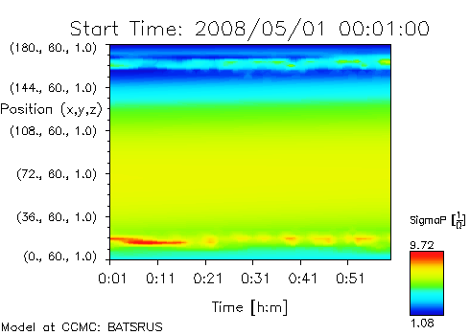

CCMCVis image (time-colatitude plot, right) is shown upside-down to demonstrate similarity:

Range (0-9.72) agrees, auroral features (near +70 degrees) stronger in North than south (near -70 degrees). Auroral conductance in the north strongest near the beginning of the 1-hour time interval. Near-equatorial band of largest (solar EUV driven) conductance is centered at about 20 degrees latitude in the North, moving slightly southward during the hour. A low-conductance background area is seen in the south below about -50 degrees latitude with the embedded auroral zone band near -70 degrees.

**CCMCVis interface to make Time-Lat plot:**   
Select time range from Date/Time1 to Date/Time2,  
select PlotMode “ColorContour (2D)”,

uncheck “Use Satellite Track”,

select Colat0=0, Colat1=180,

select longitudes MLT1=60 and MLT2=60 for a line at constant longitude.

Time-Longitude plots:

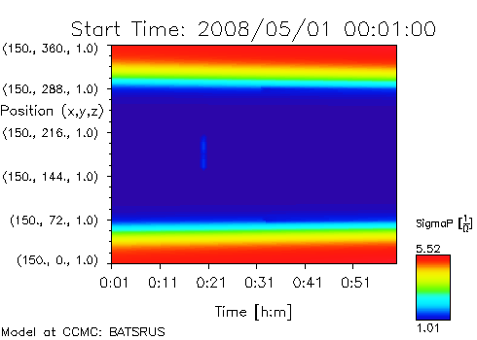

**CCMCVis Settings** (changes applied to previous plot settings):

Colat1=150, colat2=150 (equivalent to -60 degrees latitude)

MLT1=0, MLT2=360

Range (CCMCVis range is tight, but maximum seems to match.

Highest values near local noon (0 and 360 degrees). Values increase slightly for this latitude throughout the time interval (that is the southward shift seen in the time-latitude plots).

Time-Longitude plot of JR:

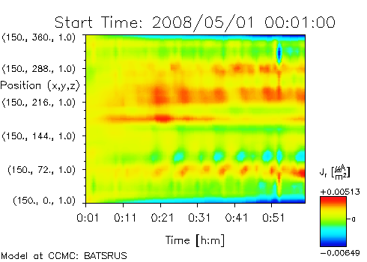

Range and time variations seem to agree and the areas of low values near the poles expand over time. In CCMCVis, data can be extracted and used for comparisons.

Request ASCII outputs from CCMCVis:

At the bottom of each form, ASCII outputs can be requested by checking “List Data”. A link to the output file is provided with each plot.

Part of the resulting ASCII file:

# Data printout from CCMC-simulation: version PD4D-1.3

# Data type: BATSRUS ionosphere

# Run name: Yi-De_Jing_042221_1

# Missing data: NaN

# Coordinate System: SM

# Dipole Time: 2008/05/01 00:58:00

# dipole tilt angles used: SM-GSM: 0.165516 GSM-GSE: 0.465086

# Output data: field with 51x60=3060 elements

# Year Month Day Hour Min Sec x y z SigmaH JR

# [year] [month] [day] [h] [m] [s] [R_E] [R_E] [R_E] [S] [muA/m^2]

2008 05 01 00 01 0.000 150.00 0.0000 1.0000 5.8999 0.0015791

2008 05 01 00 01 0.000 150.00 7.2000 1.0000 5.8702 0.0017670

2008 05 01 00 01 0.000 150.00 14.400 1.0000 5.7765 0.0011867

2008 05 01 00 01 0.000 150.00 21.600 1.0000 5.6007 0.00093912

2008 05 01 00 01 0.000 150.00 28.800 1.0000 5.3190 0.00099719

2008 05 01 00 01 0.000 150.00 36.000 1.0000 4.9155 0.0011183

2008 05 01 00 01 0.000 150.00 43.200 1.0000 4.3888 0.00094236

2008 05 01 00 01 0.000 150.00 50.400 1.0000 3.7794 0.00072635

2008 05 01 00 01 0.000 150.00 57.600 1.0000 3.1576 0.00099744

2008 05 01 00 01 0.000 150.00 64.800 1.0000 2.6120 0.0012979

2008 05 01 00 01 0.000 150.00 72.000 1.0000 2.3549 0.0011954

2008 05 01 00 01 0.000 150.00 79.200 1.0000 2.2033 0.00095039

2008 05 01 00 01 0.000 150.00 86.400 1.0000 2.1344 0.00087517

2008 05 01 00 01 0.000 150.00 93.600 1.0000 2.0977 0.0010152

2008 05 01 00 01 0.000 150.00 100.80 1.0000 2.0735 0.0012201

2008 05 01 00 01 0.000 150.00 108.00 1.0000 2.0559 0.0014241

2008 05 01 00 01 0.000 150.00 115.20 1.0000 2.0431 0.0011276

…